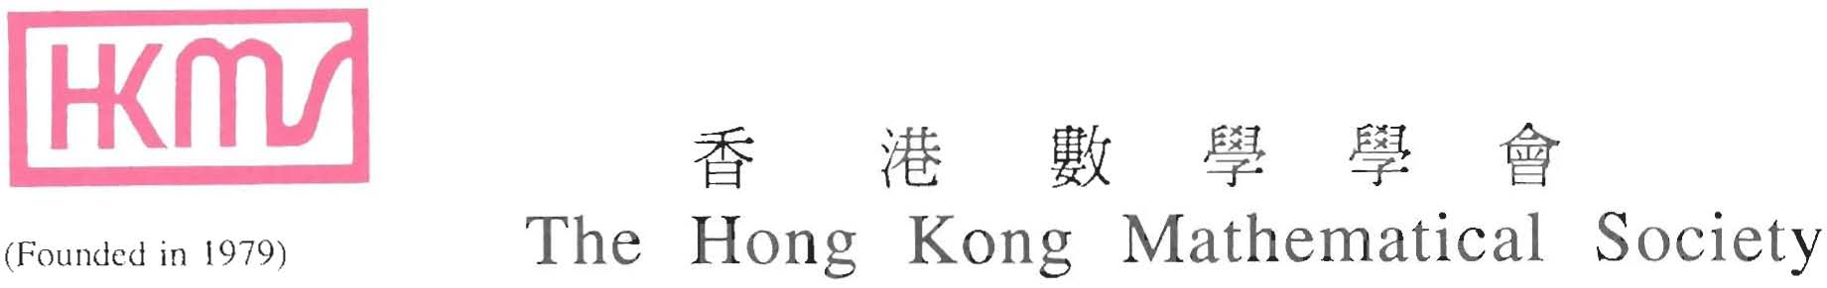

Tel: (852) 3411 5148 The Hong Kong Mathematical Society
Fax: (852) 3411 5185 c/o Rm 1102 Fong Shu Chuen Library
Email: hkms@www.hkms.org.hk HSH Campus, Hong Kong Baptist University
URL: http://www.hkms.org.hk/ Kowloon Tong, Hong Kong

Hong Kong Mathematical Society
Annual General Meeting 2011

14 May 2011 (Saturday)
2:00-6:10pm
The Hong Kong University of Science and Technology

Venue: Rooms 2406 and 2407 (2nd floor, near lift 17-18), HKUST.
Schedule of Events:
Invited Talks (Parallel Sessions):

Parallel Session 1  Venue: Room 2406  Chair: Ding-Xuan Zhou |  |  | Parallel Session 2  Venue: Room 2407  Chair: Xiaoqi Yang
2:00-2:30pm  - Jiu Ding (University of Southern Mississippi)  Title: Computing a stationary density of chaotic interval mappings by a least squares method.  Abstract: A piecewise linear least squares approximation method is proposed for computing stationary density functions of Frobenius-Perron operators associated with interval mappings. We prove the BV-norm convergence for Lasota-Yorke type mappings of the unit interval, based on the Lasota-Yorke inequality and techniques from matrix analysis. Numerical results show that the piecewise linear least squares algorithm outperforms the piecewise linear Markov type (integral and positivity preserving) method, and is much better than the classic Ulam's method in the rate of convergence.  2:30-3:00pm  - Ronald Lok Ming Lui (CUHK)  Title: Computational quasi-conformal geometry and its applications to medical morphometry  Abstract: Medical morphometry is an important area in medical imaging for disease analysis. Its goal is to systematically analyze anatomical structures of different subjects, and to generate diagnostic images to help doctors to visualize abnormalities. Quasiconformal(QC) Teichmuller theory, which studies the distortions of the deformation patterns between shapes, has become an important tool for this purpose. In practice, objects are usually represented discretely by triangulation meshes. In this talk, I will firstly describe how quasi-conformal geometry can be discretized onto discrete meshes. This gives a discrete analogue of QC geometry on meshes. Then, I will talk about how computational QC geometry can be applied to practical applications in medical shape analysis. This is a joint work with Prof. Shing-Tung Yau, Prof. Tony F. Chan and Prof. Xianfeng Gu.  3:00-3:30pm  - Dan Dai (CityU)  Title: Orthogonal polynomials and Painleve transcendents  Abstract: Orthogonal polynomials play an important role in many branches of mathematics, including mathematical physics, approximation theory and combinatorics. Recently, it is found out that they are also related to Painleve transcendents, which are regarded as nonlinear special functions in the 21st century. In this talk, I will give an introduction about their relations. |  |  | 2:00-2:30pm  - Qingshuo Song (CityU)  Title: Optimal switching with constraints and utility maximization of an indivisible market  Abstract: This work is motivated by utility maximization of an indivisible market, which is formulated as an optimal switching problem with constraints. The dynamic programming approach is used, and PDE characterization is also developed using viscosity solution techniques. The unbounded domain introduces new challenges. By studying the sample paths of the diffusion at the boundary, a sufficient condition for the continuity of the value function is provided, which in turn, provides the desired characterization. The applications of this work are not limited to the utility maximization, but include general optimal switching problems with finite regimes. This is joint work with George Yin and Chao Zhu.  2:30-3:00pm  - Shingyu Leung (HKUST)  Title: An Eulerian approach for computing the finite time Lyapunov exponent  Abstract: We propose efficient Eulerian methods for approximating the finite-time Lyapunov exponent (FTLE). The idea is to compute the related flow map using the level set method and the Liouville equation. There are several advantages of the proposed approach.  Unlike the usual Lagrangian-type computations, the resulting method requires the velocity field defined only at discrete locations. No interpolation of the velocity field is needed. Also, the method automatically stops a particle trajectory in the case when the ray hits the boundary of the computational domain. The computational complexity of the algorithm is O(1/Δx^(d+1)) with d the dimension of the physical space. Since there are the same number of mesh points in the x-t space, the computational complexity of the proposed Eulerian approach is optimal in the sense that each grid point is visited for only O(1) time. We also extend the algorithm to compute the FTLE on a co-dimension one manifold. The resulting algorithm does not require computation on any local coordinate system and is simple to implement even for an evolving manifold.  3:00-3:30pm  3. Zhi An Wang (PolyU)  Title: Stochastic and deterministic models of chemotaxis  Abstract: As a leading mechanism to account for the morphogenesis and self-organization of biological systems, chemotaxis involves both cellular (microscopic) and population (macroscopic) movement of cells. This hence led to two major categories of mathematical modeling of chemotaxis. The central question among these modeling studies is how to establish the connection between the cellular and population models.  In this talk, a full Langevin type stochastic (i.e. cellular) model will be introduced and the well-known Keller-Segel model, which was proposed by Keller and Keller in 1971 to describe the chemotactic aggregation of cell populations, will be redrived from the proposed stochastic model. The connections between microscopic and macroscopic parameters will be explicitly identified. A number of techniques, including mean-field theory, minimization principle, moment closure and scaling argument, will be presented in the talk.

3:30-3:40pm Break

Venue: Room 2406
Chair: Tao Tang
3:40-4:10pm Council Annual General Meeting
4:10-4:30pm HKMS Best Thesis Award Presentation Ceremony
4:30-5:20pm Plenary Lecture by Walter Gander (ETH, Switzerland):
Title: Basis change in polynomial interpolation
Abstract: Various representations for the interpolating polynomial exist: Lagrange, Newton, orthogonal polynomials etc. Each representation is characterized by some basis functions. In this talk we investigate the transformations between the basis functions which map a specific representation to another. We show that for this purpose the LU and the QR decomposition of the Vandermonde matrix play a crucial role.

Chair: Jianshu Li
5:20-6:10pm Plenary Lecture by Stephen Smale (CityU):
Title: On the mathematics of immunology
Abstract: We will discuss peptides and the construction of good kernels

6:30-9:00pm Dinner (Venue: Ground Floor of Academic Building, HKUST)

For more information about campus transportation, please visit:
http://library.ust.hk/info/transportation.html

For the lift map at HKUST, please refer to:

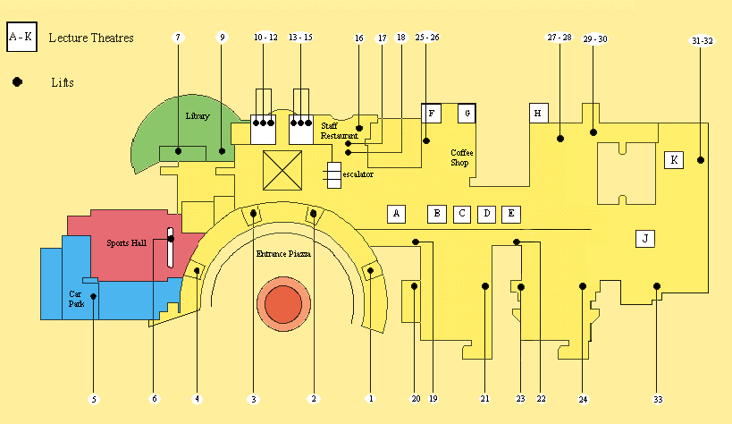

(The blue area is parking lots)

